***What’s the Buzz?***

**One-day PROFESSIONAL WTB TRAINING**

**with Mark Le Messurier and Noni Le Messurier**

**at Fullarton Park Community Centre C:\Users\Mark\Desktop\WTB For Early Learners B\Cover\Cover.tif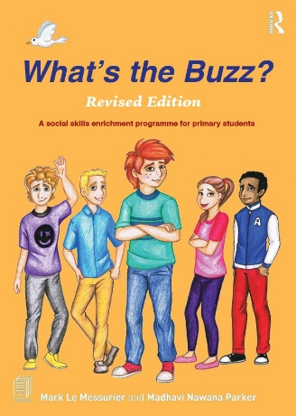(face to face)**

**Training Day opportunities available in 2025:**

**Friday 14th February (Term 1, face to face)**

**Monday 14th April (first school holidays, face to face)**

**Friday 11th July (second school holidays, face to face)**

**Friday 19th September (Term 3, face to face)**

***What's the Buzz?*** is a complete social and emotional literacy (SEL) approach comprised of 48 lessons and easy to use guided conversations over 3 programs;

***What's the Buzz?*** for EARLY LEARNERS - 16 lessons - (ages 5 to 8 years)

***What's the Buzz?*** for PRIMARY STUDENTS - 16 lessons - (ages 9 to 11 years)

***What's the Buzz?*** with TEENAGERS - 16 lessons - (ages 12 to 15 years)

This evidence-based program teaches young people social and emotional intelligence and is complimented by a deep selection of online resources. The program has also become a required text for teachers, counsellors, parents, psychologists, social workers and youth workers in training at many Universities worldwide.

It is a flexible Positive Education approach based on neuroaffirming principles where individuals come together, in a safe, structured environment to have fun, learn, exchange ideas, and to understand the beauty of each other’s diversity. 'What's the Buzz?' embraces that all human beings experience the social and emotional world differently and have the right to express their feelings and actions in their own, compassionate, way. No one prescriptive way is ever right. Our goal – “There’s 100’s of social and emotional issues that crop up in life, and there are 100’s of ways to work assertively, and kindly, with them.”

Twelve years on, after many second editions, ‘What's the Buzz?’ is now being used daily in more than 140 countries.

*PD Certificates, PowerPoints and comprehensive notes issued on completion*

**REGISTRATION - complete the form on the following page and return the Word doc. to Elissa via email at** [**registrations@marklemessurier.com.au**](mailto:registrations@marklemessurier.com.au) **or elissa@nonilemessurier.com.au**

***What’s the Buzz?***

ABN: 19 642 144 750

69 Goodwood Road

Wayville SA 5034

P: 0411 343 574

E: registrations@marklemessurier.com.au

W: www.whatsthebuzz.net.au

**REGISTRATION FORM**

*One-day PROFESSIONAL WTB TRAINING*

*with Mark Le Messurier and Noni Le Messurier*

*at Fullarton Park Community Centre (face to face)*

|  |  |  |
| --- | --- | --- |
| **PERSONAL DETAILS** | | |
| First Name |  | |
| Surname |  | |
| School/Business Name |  | |
| Postal Address (if invoicing self) |  | |
| Mobile number |  | |
| Email | Work |  |
| Personal* |  |
| **INVOICE/FINANCE OFFICER DETAILS** | | |
| Finance Officer Name |  | |
| Business Postal Address |  | |
| Finance Officer Email |  | |

***\* Please provide a personal email to ensure you receive all correspondence. We’ve learnt from experience that some school severs will block emails with attachments.***

Nominate **ONE** Training Day date:

Friday 14th February (Term 1, face to face)

Monday 14th April (first school holidays, face to face)

Friday 11th July (second school holidays, face to face)

Friday 19th September (Term 3, face to face)

**Total Cost (face to face): $350 per person (incl. GST) *group discounts available**

Please return this form via email to Elissa at [registrations@marklemessurier.com.au](mailto:registrations@marklemessurier.com.au) who will confirm your registration and issue an invoice. Once payment is received, your position is secure and Elissa will email any pre-reading and support information for the event, as well as a detailed overview of the Training Day.

This is a COVID-19 safe event. The usual protocols will be followed, such as appropriate distancing, sanitisation and face masks when necessary. We assume that your attendance indicates that you are feeling well and unlikely to have COVID-19.

**Conditions and Cancellation Policy**

Invoice MUST BE settled ONE WEEK before the Training Day, otherwise participation will not occur.

Cancellation 6 days prior to event – 25% cost retained. Cancelation less than 4 days prior to event – 50% cost retained.

Cancelation less than 48 hours prior to event – Non-refundable.